Faculty of Computing, Engineering & Media (CEM)
Coursework Brief 2024/25

Module name: | Advanced Game Engine Application
Module code: | GAMR3510
Title of the Assessment: | Develop a game in Unreal Engine using C++
This coursework item is: (delete as appropriate) |  |  |  | Summative
This summative coursework will be marked anonymously: (delete as appropriate) |  |  |  |  |  |  |  | No
The learning outcomes that are assessed by this coursework are:
- Establish a project in a game engine and accurately deploy C++ coding techniques to develop a game.
- Critically evaluate the merits of visual scripting approach and C++, choosing appropriate scenarios to implement with visual scripting and/or C++.
- Creatively and systematically demonstrate the ability to address issues that may face game designers and decide when to use this knowledge.
- Demonstrate comprehensive knowledge and understanding of further game-engine based functionalities, such as Networking and Saving Data.
This coursework is: (delete as appropriate) |  |  |  |  |  |  | Group
This coursework constitutes 100% of the overall module mark.
Date Set: |  | Monday 7th October 2024
Date & Time Due (the deadline): |  | Tuesday 19th November 2024 12.00 noon
In accordance with the University Assessment and Feedback Policy, your marked coursework and feedback will be available to you on: |  |  |  |  | Tuesday 10th December 2024
You should normally receive feedback on your coursework no later than 15 University working days after the formal hand-in date, provided that you have met the submission deadline

If for any reason this is not forthcoming by the due date your module leader will let you know why and when it can be expected. The Associate Professor Student Experience (CEMstudentexperience@dmu.ac.uk) should be informed of any issues relating to the return of marked coursework and feedback.
When completed you are required to submit your coursework via:
- A .zip file of Unreal Engine Game Project files, to be submitted on LearningZone. (week 8)

- A 6 Slides Presentation, submitted as PowerPoint on TurnIt-in via LearningZone. (6 Slides of content. Title and references are not counted as slides) (week 8).

- A 8-10 minute video demonstration submission presenting the slides and game, submitted via LearningZone. (week 8).

- Peer-Review documentation (week 8).
Late submission of coursework policy:

Late submissions will be processed in accordance with current University regulations.

Please check the regulations carefully to determine what late submission period is allowed for your programme.
Academic Offences and Bad Academic Practices:

Please ensure you read the section entitled “Academic Offences and Bad Academic Practice” in the module handbook or the relevant sections in this link: BaseCamp Link: Overview: Assessment and Good Academic Practices
Tasks to be undertaken:
See below for more details
Deliverables to be submitted for assessment:
See below for more details
How the work will be marked:
See below for more details and matrix
Module leader/tutor name: | Nasar Hasshu
Contact details: | nasar.i.hasshu@dmu.ac.uk

Should you need any further information or advice please email cemadvicecentre@dmu.ac.uk

Assignment – Develop a Game in Unreal Engine using C++

In this module we have learned about developing games using Unreal Engine’s C++ development format. For this assignment you are required to form teams of 3-4. You will be required to deploy C++ coding techniques in Unreal Engine to develop a multiplayer game with 6-8 minutes of original gameplay. You must follow these requirements for you game development:

- Use a Blank project in Unreal Engine (same version as labs) to create your game, templates are not allowed. You need to demonstrate your understanding of how games work down to the core mechanics.

- Use C++ primarily as a development format, keeping Blueprints to a minimum. You may demonstrate the use of Blueprint Callable C++ Functions and use Blueprints for Animation, UI etc. Make sure your code is: clear, concise and well commented.

- Use Enhances Input System with C++ to create your player movement bindings (as shown in the labs).

- Develop a multiplayer game allowing two or more human players to interact with your game. You must choose ONE of the following multiplayer game formats:
  - Turn based multiplayer
  - Split-screen multiplayer
  - LAN (Local Area Network)
  - Steam Multiplayer

- Developed game with 5 features (or more) implemented primarily using C++. Here are some examples of features you may add to your game:
- Leader-board
- Loading / Saving
- Player attack
- Player defence
- AI Enemy
- Shooting

  - Points system
  - Health System
  - Weapon system
  - Collect item
  - Timer
  - Power ups

- In your teams, you must demonstrate your multiplayer game and the implementation of key features of your game in C++. The demonstration must also include your presentation slides and at least 3 minutes of gameplay (your game should have at least 6-8 minutes of gameplay, but you are going to show the key aspects in the demonstration).

Unreal Engine is the module tool; however, you can use models from other modules, or those from the Marketplace, Quixel Bridge or TurboSquid, as part of your submission. You must clearly state in your slides any assets used from Marketplace or elsewhere.

DO NOT USE templates of partially or completed games, THIS WILL COUNT AS PLAGIARISM. However you can use module material.

Remember!

Components/Assets/Code of the project which are you marked on (based on the mark scheme) must be your own!

Marks:
You will receive an individual grade within the context of you team. Your submission mark will be broken down based on the mark scheme.

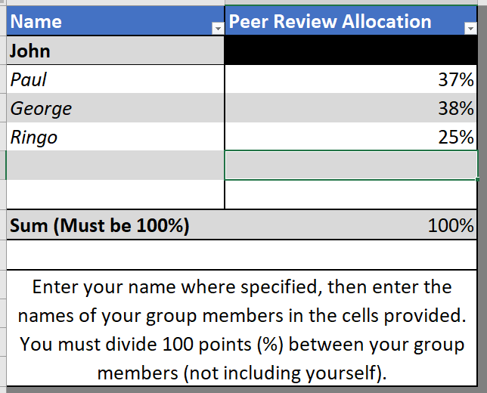
Your submission will be marked as is. The submission mark will then be scaled to achieve your individual mark. You will be required to allocate 100 points (%) between your other team members based on the amount you believe they contributed to the submission; this will be done confidentially. YOU DO NOT MARK YOURSELF. These peer evaluation scores will then be used to allocate final marks to individuals, unless the tutor has reason to believe peer evaluations have not been done confidentially or the process has not been wholly above board in any way. In this case the tutor will allocate marks.

An example of mark allocation:
On the left is an example of how each individual will complete the Peer Evaluation spreadsheet. A total of 100 points (%) is divided between the other members of the team. Below is an example of how the scale is calculated of a submission worth 67%.
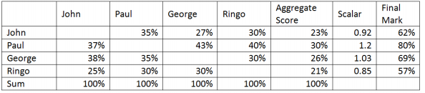

Individual marks will not exceed +10 marks for the team score. For example, Paul’s team members constantly gave Paul slightly higher contribution marks (across), so is scaled up. If the team project was scored at 67, and the matrix used to calculate the individual mark for Paul was given as 80%. The individual mark would be capped at 77% (max +10 submission). However, there is no minimum cap. This means no contribution can still lead to a failure.

Deliverables:

Zipped Unreal Project file:
- Tuesday 19th November 2024 12.00pm noon (Week 8) - Zipped Unreal Project, submission through project submission link via LearningZone. Sending via OneDrive link is recommended.

Presentation Slides (no more than 6 Slides):
- Tuesday 19th November 2024 12.00pm noon (Week 8)- 6 slides, submission through TurnItIn link via LearningZone.

Demonstration of Game & Presentation (8 - 10 minutes):
- Tuesday 19th November 2024 12.00pm noon (Week 8)- Submission through video submission link via LearningZone if you choose to record a video.

Peer Mark Allocations:
- Must be submitted using the provided template by Tuesday 19th November 2024 12.00pm noon (Week 8).

If you have issues uploading:

If you have issues uploading due to size, you may upload a document with a link to where it can be found (Dropbox, GoogleDrive). DO NOT email the link. The last modified date MUST be before the deadline, otherwise it will be classed as late.

 | 0 - 29% | 30 - 39% | 40 - 49% | 50 - 59% | 60-69% | 70 – 89% | 90 - 100%
Multiplayer  (15) | No or very little Multiplayer evidence in game | Minor attempt at Multiplayer, very incomplete implementation. | Some attempt at Multiplayer, but incomplete implementation. | Overall decent Multiplayer, but generic implementation without much innovation. | Good Multiplayer, players are able to interact, compete and distinguish a player is losing or winning. Still room for innovation, and/or some integration inconsistencies. | Excellent Multiplayer. Players are able to interact, compete and have winning and losing player states.
Implementation of Key Features  (15) | No explicit implementation of key features from the chosen genre. | Minor and/or limited implementation of key features from the chosen genre. | Some limited implementation of key features from the chosen genre (less than three). | Overall decent implementation of key features from the chosen genre (at least three implemented effectively). | Good implementation of key features from the chosen genre (at least five), but limited integration. | Excellent implementation of key features from the chosen genre., including effective synthesis of features, with vision outlined in the presentation.  Innovation, going above and beyond the specification
Consideration and Appropriation for Blueprints  (10) | No or little consideration and appropriation for Blueprints. | Minor consideration and appropriation for Blueprints, but unclear. | Limited consideration and appropriation for Blueprints. | Overall decent consideration and appropriation for Blueprints, clearly visible in implementation. | Good overall consideration and appropriation for Blueprints, and well justified. | Excellent consideration and appropriation for Blueprints, working well in conjunction with C++ code, very well justified.
C++ Code  (40) | No use of C++ Code, | Minor attempt was made to follow the Code examples in Labs, no comments, and/or partially incomplete code. Enhanced input system not used. Lack of optimisation. | Some attempt was made to follow the Code examples in Labs, no comments, and/or partially incomplete code. Partially implemented Enhanced input system. Little optimisation. | A reasonable use of C++ Code within Unreal, but not much understanding outside what was done in Labs, and/or limited commenting. Enhanced input system implemented and somewhat functioning. Decent optimisation. | Overall, a good use of C++ Code within Unreal, attempts at innovation, but minor consistency issues. Enhanced input system implemented and functioning as intended. Good optimisation. | Excellent use of C++ Code within Unreal, with an effective use of comments and high-level of professionalism, with some innovation. Enhanced input system fully implemented. Excellent optimisation.
Presentation Slides  & Demonstration  (20) | No or very poor presentation. No Demonstration | No clear vision or incorporation of the presentation. No/Poor Demonstration. | A minor attempt however lacks descriptions, critical analysis of implementation and structure. Poor grammar and/or expression problems. Poor Demonstration. | A reasonable attempt at a presentation with some descriptions, critical analysis of implementation and structure. Some grammar and/or expression problems. Reasonable Demonstration. | Overall, a good attempt at a presentation with good descriptions, critical analysis of implementation and structure but minor grammar and/or expression problems. Very good Demonstration. | Excellent presentation with excellent descriptions, critical analysis of implementation and structure with excellent use of grammar, formatting and clarity of expression. Excellent Demonstration.
Coursework Marking Scheme

